

**Artificial Intelligence and Data Science Department.**

OOPM / Odd Sem 2021-22 / Experiment.

YASH SARANG.

47 / D6AD.

EXPERIMENT - 7.

**____________________________________________________________**

**AIM:** Program to demonstrate multiple Inheritance (using Interfaces).

**____________________________________________________________**

**THEORY: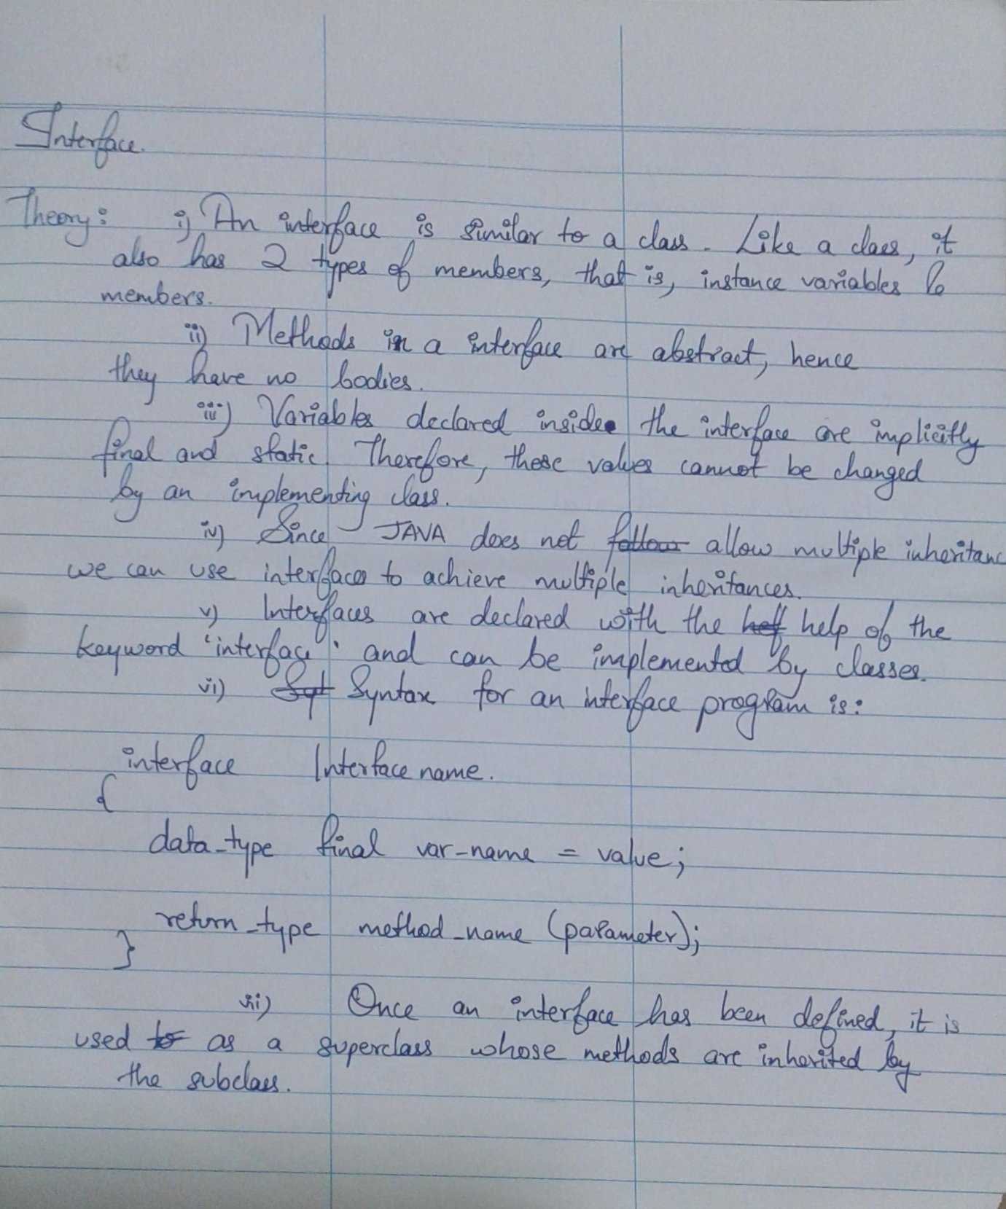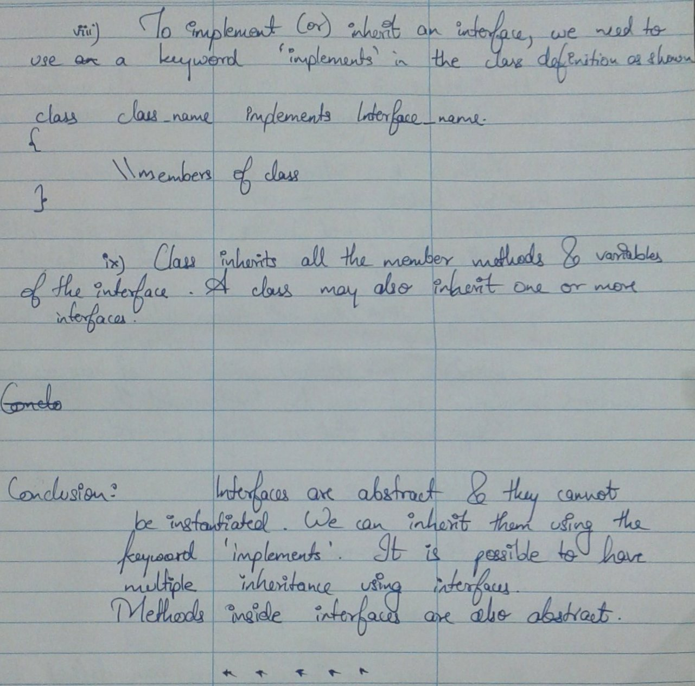________________________________________________________**

**Program 1:**

import java.util.*;

interface Printable

{

void print();

}

interface Showable extends Printable

{

void show();

}

class extendedinterface implements Printable,Showable

{

public void print()

{

System.out.println("Hello");

}

public void show()

{

System.out.println("Welcome");

}

public static void main(String args[])

{

extendedinterface obj = new extendedinterface ();

obj.print(); obj.show();

}

**}**

**The output of program 1:**



